# ATTENDANCE MANAGEMENT SYSTEM

## Mini Project Report

***Submitted by***

# SURBHIT DAVE (RA1911003010773) ARYAMAAN PANDEY (RA1911003010774) SAURABH DUA (RA191003010775)

Course: 18CSC3003J Database Management Systems

## COLLEGE OF ENGINEERING AND TECHNOLOGY



S.R.M. Nagar, Kattankulathur, Chengalpattu District

## May 2022

Declaration

I/We declare that “**RTO MANAGEMENT SYSTEM**” is the bonafide work of

SURBHIT DAVE(RA1911003010773)

ARYAMAAN PANDEY(RA1911003010774)

SAURABH DUA(RA191003010775)

Signature of the students

TABLE OF CONTENTS

|  |  |
| --- | --- |
|  | Abstract |
|  | Table of Contents |
| **1** | Objective |
| **2** | Modules |
| **3** | Requirement and Technology used |
| **4** | Tables and Front end Screen shots |
| **5** | References |

**ABSTRACT:**

RTO Management System will be a system menu-driven software for the hassle-free management of vehicles registered under the RTO. With minimal steps and maneuver to the desired function by the user, this system will highly minimize the confusion. With clear options and smooth interface, it enables editing, modifying, adding, removing and overall managing of any vehicle registration with full details on the vehicle owner, their address and other things. Easy access to all services and facilities offered by the system will increase the RTO efficieny by many folds. The program is enabled to retrieve and access information from a given RTO database and also edit its content at all points of time. With a clearly specified working description and a menu manual, even a user with zero prerequisite knowledge on the subject will be able to access all the functions of the program.

# OBJECTIVE OF THE PROJECT -:

Faulty and Rugged RTO Management Software with complicated access and functioning compatibilities; resulting in inefficient services and loss of time. Slow and Dull admin login websites at RTO due to tons of stagnant data stored daily. Confusing and unclear functions on site resulting in improper service, leading to waste of time and resources Multiple and duplicate accounts getting created without a proper check, facing cancellation and penalty.

Long lines and hefty paper works, resulting in illegal vehicle registrations as a alternative for people.

Unsystematic procedure in services creating disarray in people and officials irrespective of the user.

Faulty and unsorted databases hindering services due to unsynced software updates.

# MODULES:

* The sample UI and the frontends, are designed to ascertain the plausible funtions and services to be involved in the code.
* Their joining code in python for the working and implementaion are finalized.
* **Mainly the login and registratin portals for the admin and user staff are considered.**
* **This step will facilitate the further UI designs to base the classes and fucntions to be needed in the service initiation portals**
* **System functions which are menu driven and connect the different windows.**
* **Paid services and fees calculation module integrated in all windows**
* **Variables and items creation to be stored in the database and taken as input from the user.**
* **System reports and notifications, enabled messageboxes for better User Experience.**

### Other Features:

There are other various features that are provided in this attendance management system like updating results and checking results by the students. Paying fees either by online mode or by offline mode.

ER DIAGRAM

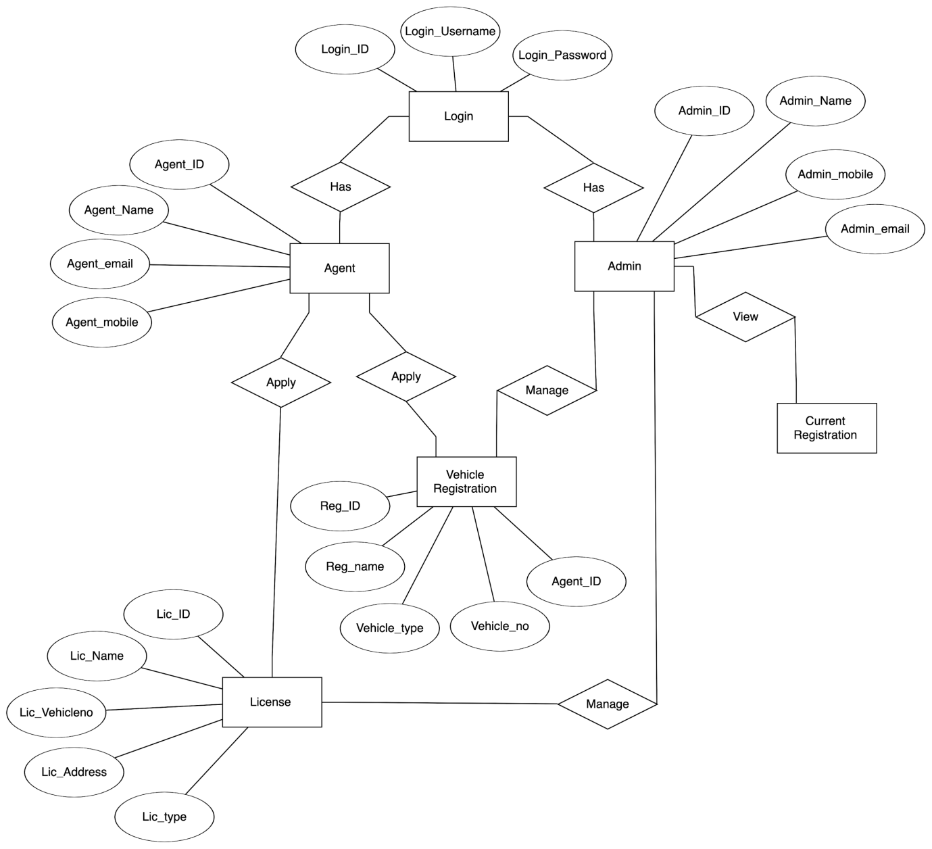

**USE CASE DIAGRAM:**

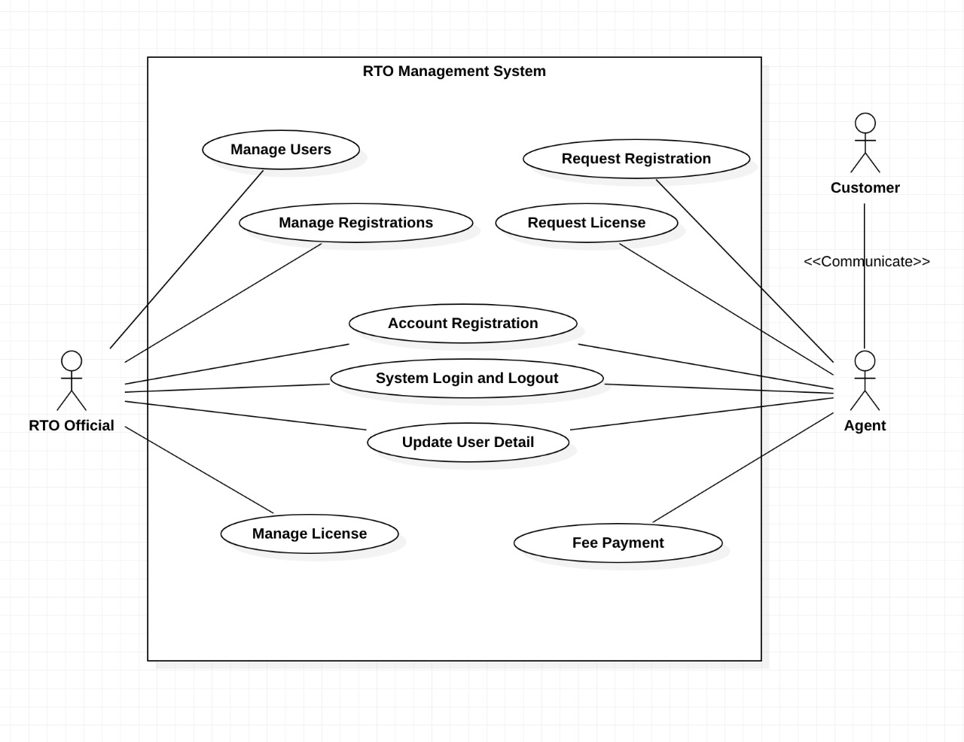

# ACTVITY DIAGRAM:

# ActivityDiagram1

# REQUIREMENTS:

# 

**TECHNOLOGIES USED:**

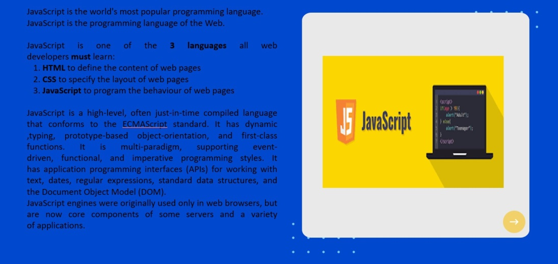

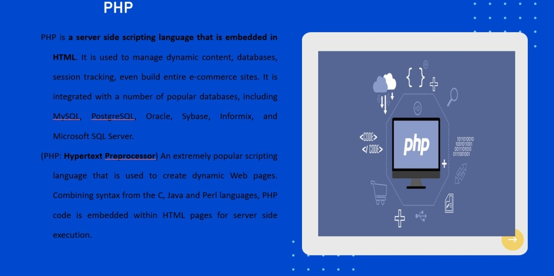

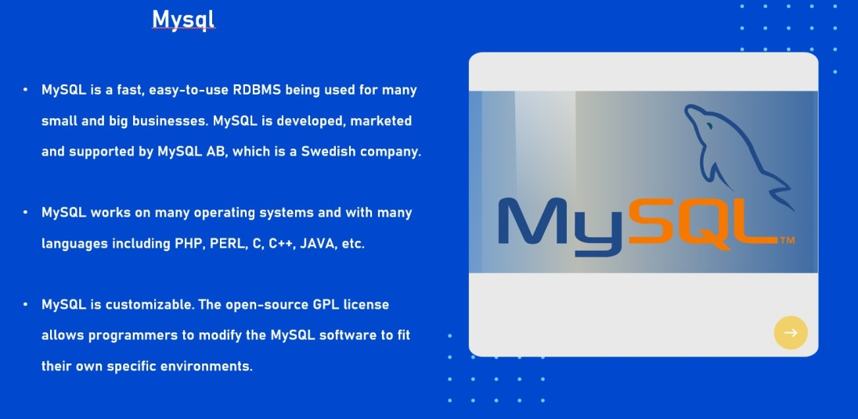

**Tables and Front end (if used) Screen shots:**

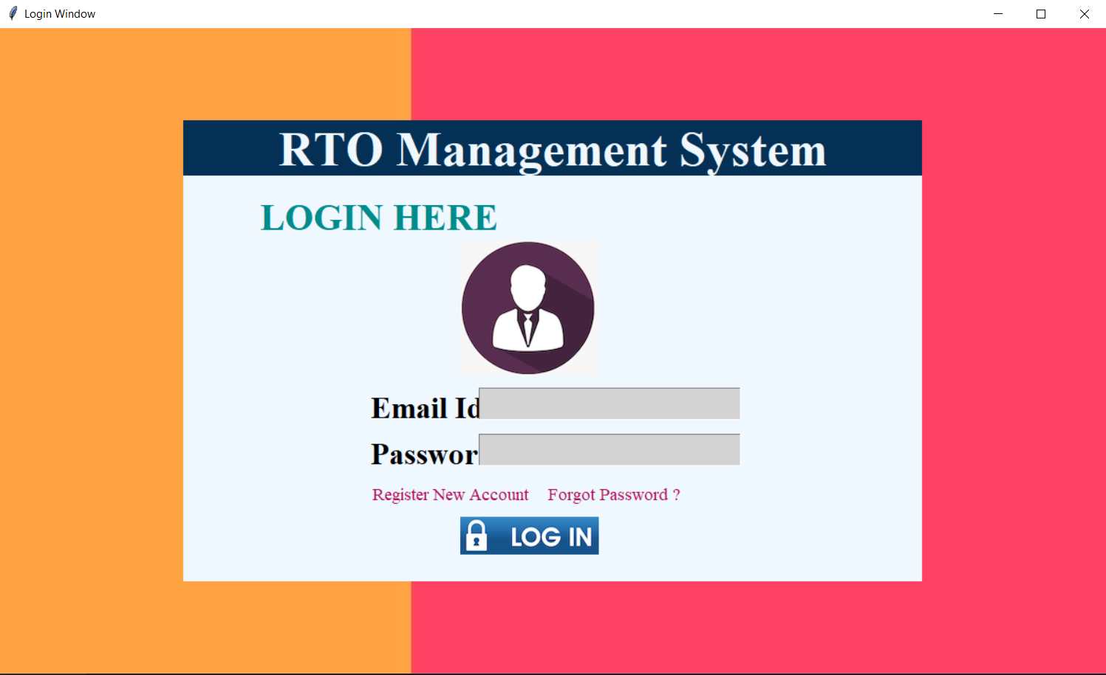

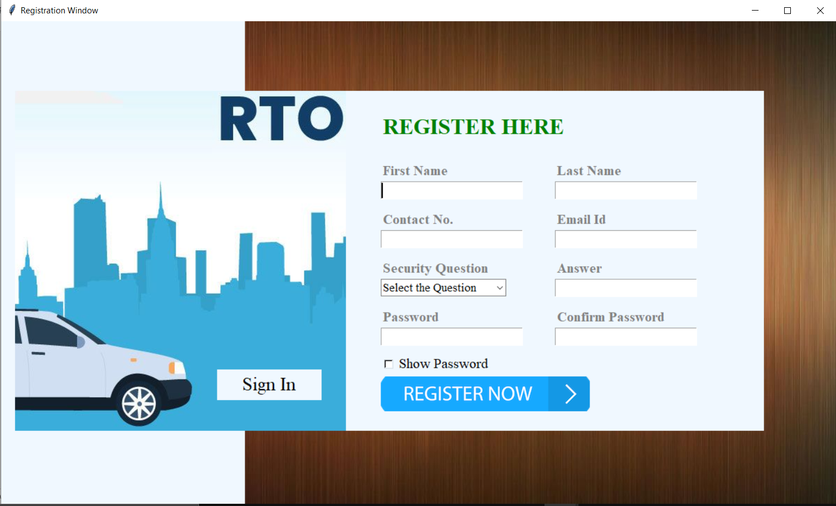

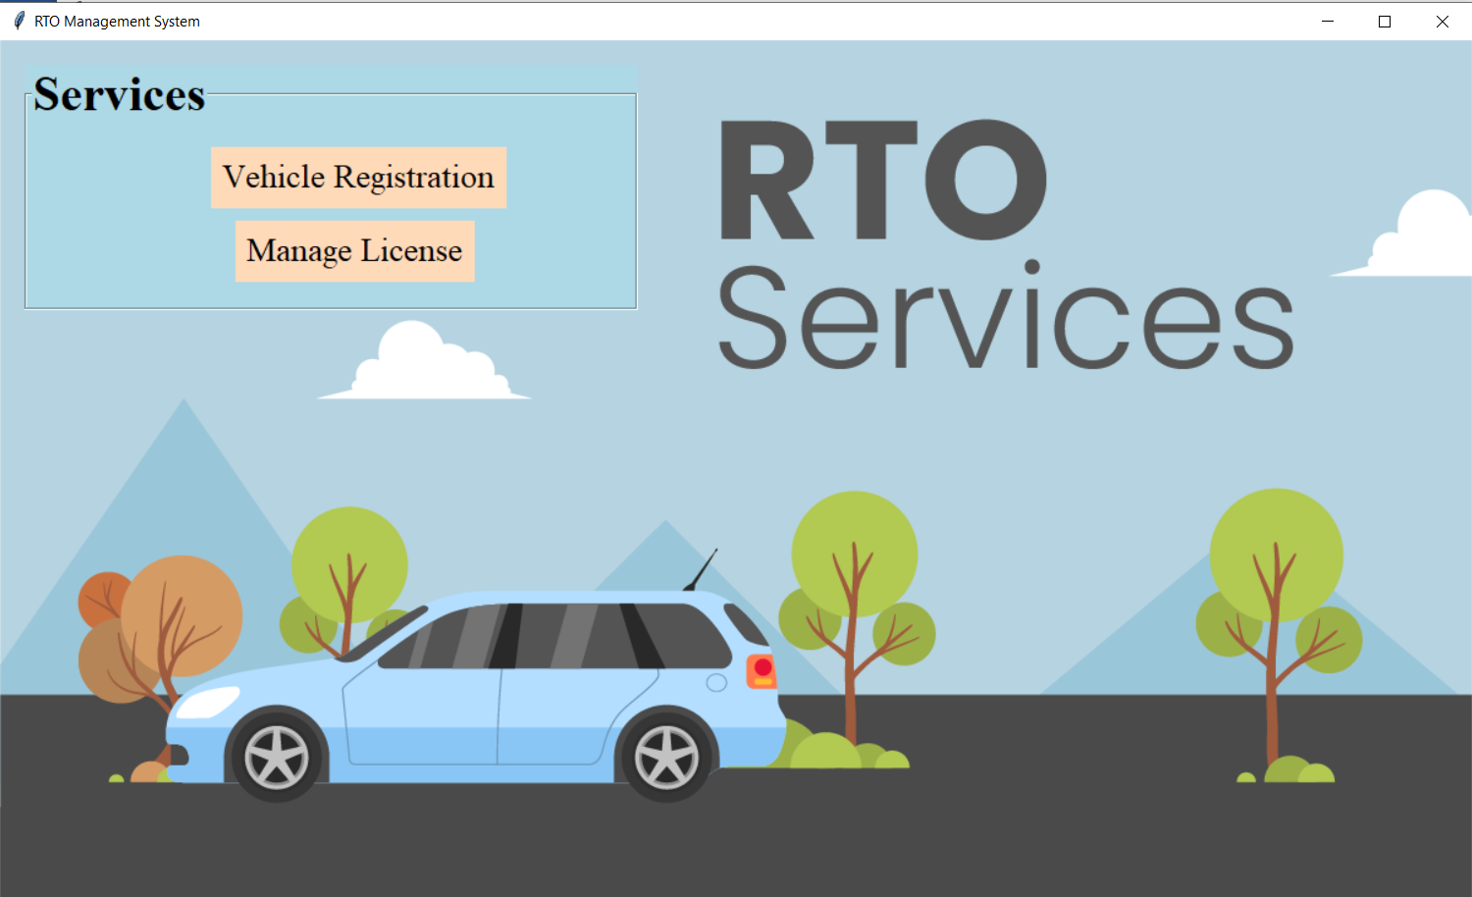

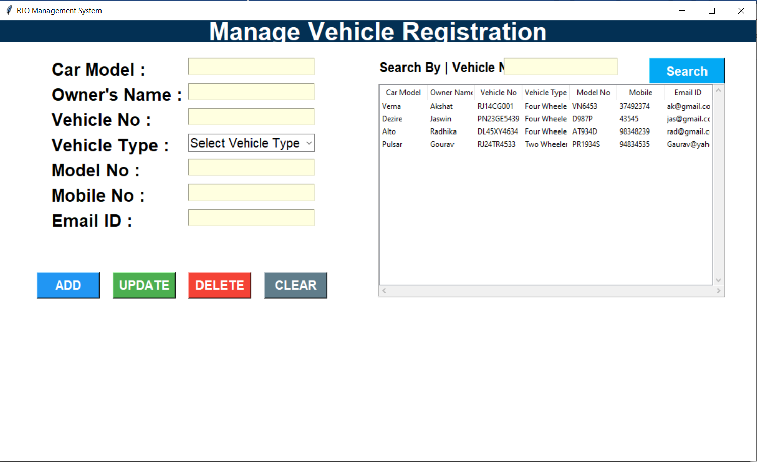

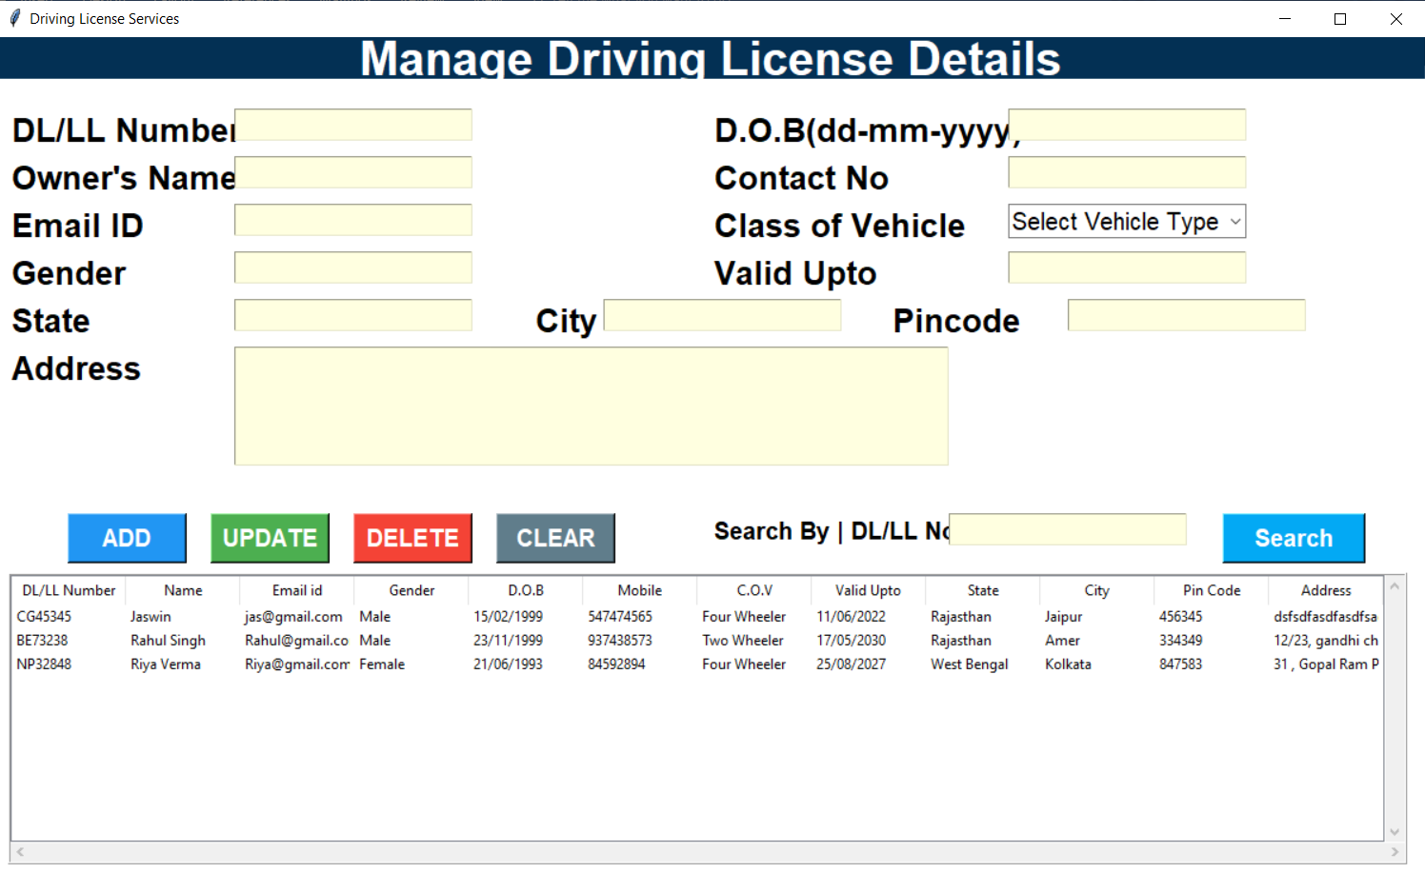

**REFERENCES**

<https://www.researchgate.net/publication/303023739_Web-based_Attendance_Management_System>

https://www.brio.co.in/why-is-online-attendance-management-system-important/